# **Python NumPy, Matplotlib – Practice Questions**

1. Write a Python program that creates a NumPy array from a list of numbers and calculates the mean, median, and standard deviation of the elements.
2. Find the number of occurrences of a sequence in a NumPy array

Eg: Arr = [[2,8,9,4],

[9,4,9,4],

[4,5,9,7],

[2,9,4,3]]

and the seq = [9,4] then output is 4.

1. Find the k smallest values of a NumPy array
2. Calculate the sum of the diagonal elements of a NumPy array

Eg:

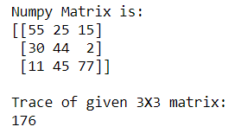

1. Find indices of elements equal to zero in a NumPy array
2. Calculate the Euclidean distance using NumPy
3. Create two NumPy arrays of the same shape and perform element-wise addition, subtraction, multiplication, and division operations on them.
4. Calculate the determinant and inverse of a square matrix using NumPy functions.
5. Generate Random Numbers from the Uniform Distribution using NumPy
6. Simulate rolling a fair six-sided die 1000 times and count the occurrences of each number.
7. Write a program that uses Matplotlib to create a simple line plot of a set of data points
8. Create a scatter plot with labeled data points, adjusting the colors and markers.
9. Save the Company Sales Data in csv file.

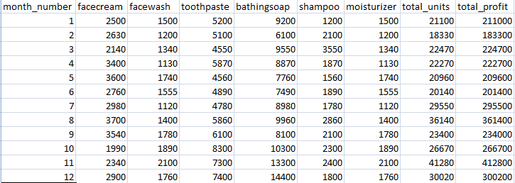

* 1. Find Total profit of all months and show it using a line plot.Generated line plot must include following Style properties: –
* Line Style dotted and Line-color should be red
* Show legend at the lower right location.
* X label name = Month Number
* Y label name = Sold units number
* Add a circle marker.
* Line marker color as read
* Line width should be 3
  1. Display the number of units sold per month for each product using multi- line plots. (i.e., Separate Plotline for each product ).
  2. Calculate total sale data for last year for each product and show it using a Pie chart

1. Load an image as a NumPy array and apply a grayscale filter to it.
2. Load an image as a Mumpy array. Perform image manipulations such as cropping,resizing and color channel conversions. Visualize the original and modified images using Matplotlib.
3. Plot a complex number in Python using Matplotlib ?
4. Normal Distribution Plot using Numpy and Matplotlib